SCH4U – VSEPR Theory

Draw the Lewis structure and structural formula for CH₄

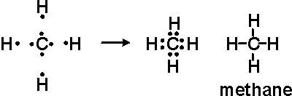

A structural formula represents the _3D___ structure of a molecule.

Explain why the structural formula of a molecule does not represent the true picture of what a molecule looks like:
It does not show the angles that each atom is at in respect to the central carbon. Nor does it show the position of the atoms in space.

The type of bonds in a molecular structure (ionic, covalent, metallic) play a role in the properties of that substance such as:

- Electronegativity
- Boiling/Melting Points
- Polarity

The 3-D structure of a substance has an impact on the properties of a substance such as:
- Polarity
- Reactivity

VSEPR Theory

VSEPR theory allows chemists to predict _the molecular structure_.

VSEPR is an acronym for:
Valence Shell Electron Pair Repulsion
V_____________ S__________ E___________-P_________ R__________________

Explain VSEPR theory:
VSEPR theory predicts molecular shapes by arranging the atoms around a central molecule in such a way as to reduce the repulsion between neighbouring electron groups. Electron groups consist of either bonding pairs of electrons or lone pairs of electrons (keep in mind that a double or triple bond only count as single electron group). A simple way of thinking of VSEPR theory is that electron pairs want to be as far away from each other as possible because they have the same charge and we can predict the shapes of molecules based on this repulsive effect. However, not all electron groups are created equally, it turns out that lone pair electrons have a stronger negative charge than bonded electron pairs, so these lone pairs actually have a stronger repulsive effect.

What is a bond angle?
A bond angle is the angle formed between three atoms across at least two bonds
Steps for Applying VSEPR Theory:

- Draw the structural formula for BeCl₂:
- Draw the simplified Lewis structure of the molecule.
- Count the electron pairs surrounding the central atom including both bonded and lone pair electrons.
- Arrange the surrounding atoms and any lone electron pairs around the central atom to minimize the repulsion between them by placing them as far apart as possible in 3-D space.
- Determine the name and bond angles of the structure from the positions of the atoms and the lone pairs of electrons.

Draw the 3-D shape of BeCl₂ predicted by VSEPR

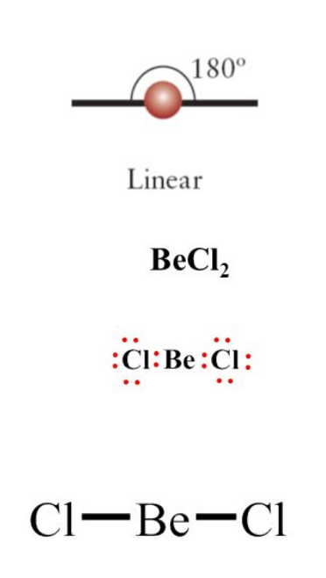

Name:___Linear___; Bond angles_180__

Draw the structural formula of BF₃ (*Note in this molecule, boron does not have a stable octet.)
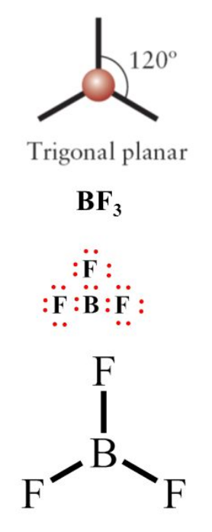

Does this structure minimize the repulsion between bonded electron pairs?
Yes

To minimize the repulsion of bonding electrons, BF₃ forms a 3-D shape known as
Trigonal Planar__. Which has bond angles of:_120_

Look at the structural formula for CH_{4.} What are the bond angles in this structure 109.5_
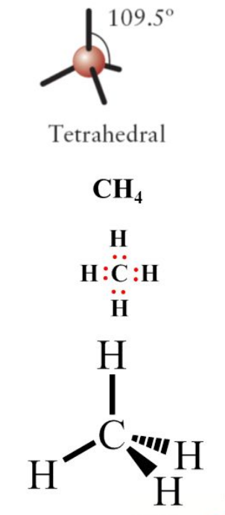
Does this arrangement minimize repulsion of bonding electrons?
Yes
Using 3-D space the bond angles can be _____________ and the bonding pairs can be placed even further away from each other.

Draw the 3-D structure for CH₄ as predicted by VSEPR:

See Above*

Structure name:__Tetrahedral___ Bond angles__109.5__

Rules for drawing VSEPR shapes:

Bond is in the plane of the paper (or screen) | 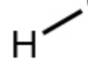
Bond extends backwards into the paper (or screen) | 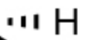
Bond extends outwards (out of the paper or screen) | 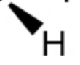

VSEPR Theory – Lone Pairs

Only lone pairs on the ___Central Atom__ affect the 3-D shape of a molecule.

Draw the structural formula for NH₃:

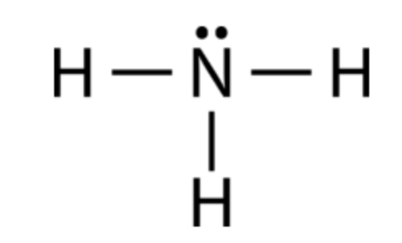

Predict the 3-D shape and bond angles of this molecule:

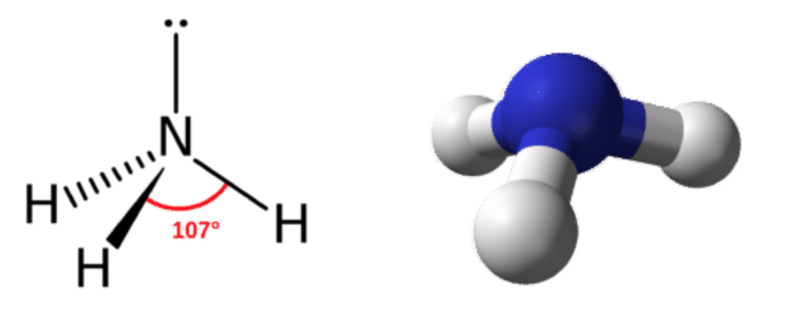

Name:__Trigonal Pyramidal__; Bond Angles_107__
Draw the structural formula for H₂O

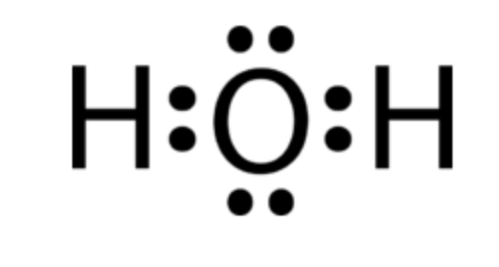

Predict the 3-D shape and bond angles of this molecule:
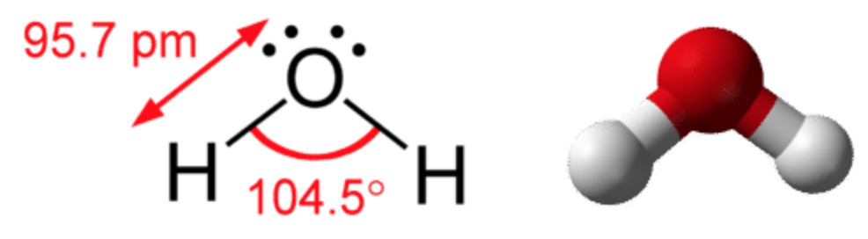

Name:__Bent_; Bond angles:_104.5__

Using the VSEPR Simulator (https://phet.colorado.edu/sims/html/molecule-shapes/latest/molecule-shapes_en.html) Complete the following table by adding bonds and lone pairs of electrons.
Note: in the “Model” tab, not all bond angles are incorrect, consider the bond angles already included in the table the correct ones.

ANSWER KEY BELOW**
Total # of e⁻ pairs | # of lone pairs | Name of Structure | Bond Angle | 3-D Shape
2 | 0 | Linear | 180˚ | X-A-X
3 | 0
3 | 1 |  | 120˚
4 | 0
4 | 1 |  | 107˚
4 | 2 |  | 104.5˚

Total # of e⁻ pairs | # of lone pairs | Name of Structure | Bond Angle | 3-D Shape
5 | 0 |  | 90˚, 120˚
5 | 1 |  | 90˚, 180˚
5 | 2 |  | 90˚, 180˚
6 | 0
6 | 1
6 | 2

